DIVE PLAN
2026 PSUBS CONVENTION
FEBRUARY 11-15, 2026

- EVENT SUMMARY
  - Location.
The base of operations will be at a residence located in Islamorada, FL. There is space to both park and work on the submersibles on a next-door lot also owned by our hosts.

We anticipate ocean dives will launch from any of the following sites:
Islamarine Marina: 85920 Overseas Hwy, Islamorada, FL 33036
Harry Harris State Park: 50 E Beach Rd, Tavernier, FL 33070
Bahia Honda State Park: 36850 Overseas Hwy, Big Pine Key, FL 33043

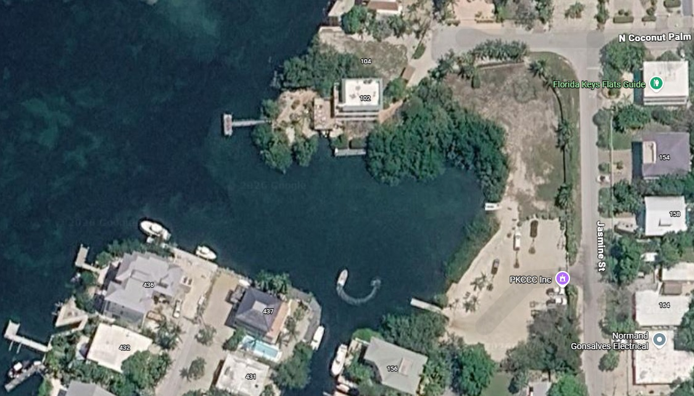

  - Purpose / Mission.
The purpose of the event is to foster knowledge transfer and camaraderie between members of the PSUBS community. Two of the submersibles present, Aquatic and Snoopy, have just been overhauled. A secondary objective is to conduct sea trials to confirm that their systems are working as intended and dial in their buoyancy.
- CHAIN OF COMMAND
  - Surface Operations Coordinator (SOC).
The SOC is responsible for oversight of all segments of dive operations, and the final arbiter and decision maker for all matters. The SOC monitors weather, boat traffic, and any other events on the surface that could impact submersible operations. The SOC also coordinates dives with submersible pilots as well as acting as a liaison with all parties on the surface.

  - Pilot in Command (PIC).
To the extent necessary to address an emergency or immediate safety concern, the PIC may override any directive, including those issued by the SOC. Submersible pilots shall be responsible for all decisions regarding the operation of their vessel.

  - Dive Master (DM) / Safety Divers.
The DM is responsible for coordination of in-water safety operations. The DM may delegate roles and responsibilities of other safety divers as necessary. The DM reports to the SOC.

Safety Divers help with tasks that require a person in the water, such as during launch and retrieval, attaching or casting off tow lines, or replacing air cylinders on a submersible. The Safety Diver is available for rescue tasks in case of emergency. The Safety Diver reports to the DM or SOC as appropriate.

  - Underwater Communication Officer (UCO).
The UCO is responsible for all underwater communications with submersibles and tracking dive times on a clipboard, using the call sign “Topside”. The UCO reports to the SOC.

- SAFETY / EMERGENCY
  - Emergency Event.
Only the SOC may declare an emergency event. Should it require external support, the SOC will contact public services by making a 911 call and initiating a call to the USCG on channel 16. In the event cell phone coverage is not available within a specific dive location, arrangements shall be made to relay calls for help via Marine VHF radio to a contact on shore with adequate cell phone coverage to call 911.

  - Emergency Activation Trigger.
    - If communication established:
Pilot reports a disabling event requiring external help.
    - If communication lost:
Vessel is 30 minutes overdue of their scheduled surface time.

  - Emergency Coordination.
Coordination between emergency responders and the dive area should be routed through the SOC when possible, to facilitate a common chain of command and help prevent miscommunication.

- VESSELS
  - Submersibles.
Three submersibles will participate in the overall event, however only one will dive offshore.

- Aquatic is a Kittredge K600 one-man submersible with 600-foot depth capability, piloted by Jon Wallace.
- Snoopy is a Kittredge K250 two-man submersible with 250-foot depth capability, piloted by Doug Suhr.
- Shackleton is a two-person submersible designed to operate at 1000-foot depth, but currently rated to 375 feet because her deepest unmanned test to date has been 500 feet. She is piloted by Alec Smyth.

Aquatic and Snoopy have just been refurbished and will only perform qualification dives in the safety of a protected canal at the Suhr residence base of operations.
Shackleton is already qualified for ocean dives.

  - Surface Support.
Three surface boats will participate in the event. One boat will be used for towing Shackleton to the dive site. The other two boats will serve as observation platforms and carry both the dive support team (SOC, DM, UCO) and spectators.

All surface vessels shall comply with USCG boating safety regulations.

- DIVE OPERATIONS
  - Vessel Emergency Plan.
All submersibles will provide a vessel-specific emergency plan to the SOC. The plan will list specifications, features, and safety-related protocols. Both SOC and Safety Divers must be intimately familiar with the details of their assigned submersible and the contents of its Emergency Plan.

  - Jurisdiction Compliance.
All submersibles should be in compliance with governmental laws, regulations, and guidelines applicable within the local jurisdiction.

  - Protection of the Marine Environment.
- On all dives, pilots will avoid any contact with the bottom and maintain a respectable horizontal distance from any reef.
- Submersibles shall maintain positive buoyancy at all times to ensure:

in the case of thruster failure or lack of pilot input, the submersible will rise rather than settle towards the bottom.

prop wash is directed upwards, preventing silt-up.
- All surface vessels shall use mooring buoys or drifting over the dive site. No anchors are to be used.
- Submersibles shall tie-off to surface vessels.
- Zero discharge allowed from both surface vessels and submersibles.

  - Equipment.
    - Communications.
All submersibles should possess marine VHF radio for surface communications, and Ocean Technology Systems underwater radio for subsurface communications.

    - Location Device.
All submersibles must have equipment capable of guiding rescuers to their position should they experience an emergency. These devices may be electronic, or a releasable float.

  - Communications.
    - Surface.
VHF surface communication will occur on channel 68 by default. However, actual communication traffic on the day of the dive may require changing to a different channel. Any change from channel 68 to an alternate channel will be determined and communicated by the SOC.

At least one independent VHF radio shall monitor VHF channel 16 at all times.

    - Underwater.
All submersibles will be carrying Ocean Technology Systems (OTS) equipment. By default, Sub-surface communications will be on ultrasonic frequency 32.768 khz, which is OTS Channel 1.

    - Loss of Communication.
If underwater communication is found to be non-operational on site, dives shall be limited to durations of 30 minutes and strictly adhered to. Pilot and SOC shall set timers at the start of each dive and after the set duration has elapsed the submersible shall surface promptly.

  - Surface Support Vessels.
The surface support vessel carrying the SOC and Safety Diver shall:
- Remain with the submersible at all times.
- Handle communications with the assigned submersible.
- Be the submersibles “eyes on the surface,” for instance advising of approaching boat traffic when the pilot plans to surface.
- Fly a “Diver Down" flag.

  - Morning Briefing.
A pre-dive briefing shall be held each day before leaving the dock, to:
- Identify surface support personnel (SOC, DM, UCO, Safety Divers)
- Identify surface support vessels and crews
- Establish working VHF channel (default is #68)
- Review dive site information, planned activities, and emergency protocols

  - Dive Site Procedures.
Upon arrival at the dive site:
- Water Depth shall be ascertained and communicated to all vessels prior to commencement of any dive.
- The SOC shall determine the general perimeter of the dive area and submersibles shall operate only within this perimeter unless otherwise coordinated with the SOC. In the case of a transect the support vessel will shadow the submersible using whichever method proved most satisfactory in Day 1 tests.
- Prior to diving, any obstacles or obstructions visible at the surface shall be communicated to all vessels by the SOC.
- Surface support vessels shall maintain adequate clearance from the estimated position of safety divers and submerged submersibles at all times, and keep stations at the perimeter of the dive site when possible.
- Prior to a dive, the pilot and SOC agree on details such as intended course and dive duration. Once these are mutually established, the pilot will request permission to dive.
- Each submersible shall perform a radio check with the SOC immediately prior to commencement of a dive, and an underwater comms check immediately after submerging. If underwater comms are not functional, the submersible will surface to coordinate next steps.
- Any extension of a dive in progress shall occur only upon agreement between pilot and SOC via underwater communications.
- At the end of the dive, the pilot shall request permission to surface. The SOC shall check for boat traffic prior to authorizing ascent

- DIVE SCHEDULE
  - Day 1 – February 11, 2026
Sea trials and qualification dives at Harry Harris State Park. All three submersibles will “dunk test” in a protected canal to test components and configure weight to establish neutral buoyancy. Aquarius and Snoopy’s pilots will go through a qualification checklist.

Maximum Depth: 15 feet
Departure Time: 8:00 am
Est. Return Time: 4:00 pm
GPS Coordinates:

  - Day 2 – February 12, 2026
Ocean dives by Shackleton out of Harry Harris State Park, maintaining a respectful distance from any Special Preservation Area. Planned location is subject to change due to ramp availability, weather, and water conditions.

Maximum Depth: 75 feet
Departure Time: 08:00
Est. Return Time: 16:00
GPS Coordinates: 24.994571703019766, 80.43723715859839

  - Day 3 – February 13, 2026
Ocean dives by Shackleton out of Harry Harris State Park, maintaining a respectful distance from any Special Preservation Area. Planned location is subject to change due to ramp availability, weather, and water conditions.

Maximum Depth: 75 feet
Departure Time: 08:00
Est. Return Time: 16:00
GPS Coordinates: 24.994571703019766, 80.43723715859839

- LOCAL RESOURCES
  - Non-Emergency Services.
Police (305) 664-6480 86800 Overseas Hwy, Islamorada
Fire/Rescue (305) 664-6490 81850 Overseas Hwy, Islamorada

  - Air Refills.
Available at Suhr residence

  - Oxy Refills.
Polo Gas Welding Supply (305)246-7845 129 SW 3rd Ave, Homestead
Open 8:00-4:30
  - Hardware Stores.
Keys Mercantile
Tavernier Ace

