What is PSUBS.ORG?

- Personal Submersibles Organization

But what is PSUBS ORG about? What is its mission?

- To promote and encourage the discussion, design, construction, certification, ownership and use of Personal Submersibles.
- Discussions range from unmanned, manned, wet, ambient, 1atm submarines. One, two man, to crew served submarines.
- Topics cover life support, motor selection, view ports, battery selection, hull material....

Who are the members?

- You
- All persons signed up on the listserver alias personal_submersibles@psubs.org

What is WWW.PSUBS.ORG?

- Web site that contains:
- Pictures
- Listserver archives
- Contact information
- Managed by:
- Ray Keefer
- Jonathan Wallace

Why start a web site? Maintaining the web site is a lot of work!

- Labor of love
- Best way to avoid mistakes is to share knowledge of what works
- and to hand out cautions for dangerous or unworkable ideas

How did PSUBS.ORG come into existence? What is the history?

- A bit muddled because never realized what PSUBS could become thus was not careful to save initial documentation.
- Four people met on rec.boats.building
- Summer1996. Earliest date confirmed on rec.boats.building was 02 Oct 1996.
- Ray Keefer
- Jonathan Wallace
- Martin Sanderse
- Gary Boucher
- The group took the discussions off line of rec.boats.building since really not in that group's charter. The early discussions were by email.
- When the initial discussions seemed worthy of capture, two websites were attempted.
- One attempt failed.
- The attempt by Ray Keefer succeeded by focusing on plain simplicity over fancy whiz-bang looks. Content over fancy.
- Soon the content of the site overwhelmed the meager 20MB allotment with the ISP in use. Jonathan Wallace graciously offered to host PSUBS on his whoweb server at Advanced Digital Research. Our email address became known as personal_submersibles@whoweb.com
- On 11 February 1997, Jonathan Wallace started the automatic archiving of the listserver discussions.
- Officially registered Domain Name psubs.org with InterNIC in October 1997. The listserver email alias became personal_submersibles@psubs.org.
- On 12 September 2001, cancelled the first attempted PSUBS Convention in Vancouver, BC, Canada for lack of help. Staff committed to hold future conventions locally on alternating coasts to assure appropriate resources.
- In December 2001 the PSUBS Store was opened to offset costs of Domain Name registration.
- On 02 Jan 2002, officially posted winners of the 2001 Award Plaques. The winners were:
- Bill Gifford - Best Design of 2001
- Carsten Standfuss - Best Discussion Contributor of 2001
- George Kittredge - 2001 Lifetime Achievement Award
- Pat Regan - Best Pre-2001 PSUB
- Dale Heinzig - Best PSUB of 2001
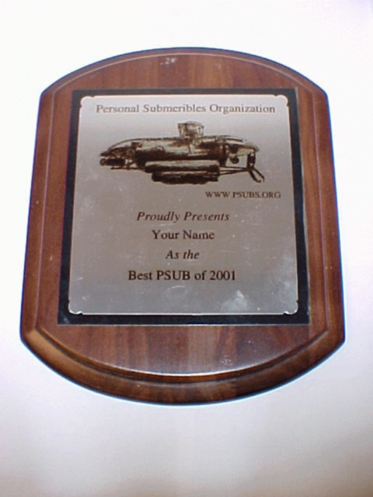

- On 09 Apr 2002, Doug "Sea Lord" Farrow announced to the PSUBS community that he came into possession of over 200 “virgin” copies of R. Frank Busby’s Manned Submersibles. Doug proposed a method of distributing these books at shipping cost.
- On 16-18 August 2002, 1ST PSUBS Convention in Portland, Oregon. Everyone had fun. Everyone wished there had been subs.
- On 9 Jan 2003, officially posted winners of the 2002 Award Plaques. The winners were:
- Dave Walls - Conference Organizer
- Doug "Sea Lord" Farrow - Custodian of the "Lost Busby's"
- Carsten Standfuss - 2002 PSUBS Kittredge Award
- William Alford - 2002 PSUBS Busby Award
- On 15-17 August 2003, 2nd PSUBS Convention in Manchester, New Hampshire.

Listserver Discussion Topics Include

- OSS (Open Source Submarine)
- Life support
- Propane Tanks and why not to use them
- Motor selection
- Motor compensation
- Batteries
- Unit Conversion
- Jokes
- Alternate power sources to batteries:
- Hydrogen fuel cells
- Hydrogen Peroxide
- Chemical
- Hardware
- Hull
- Valves
- Viewports
- Software
- CAD packages
- Computer control
- Ballast tanks
- Hard
- Soft
- Variable
- Hi, I am a Newbie
- I have pictures

Logos

- 1996-2001
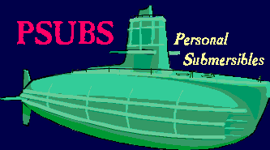

- 2001-2001


- 2001-Current


Statistical Trends

- Currently there are 211 Listserver subscribers
- Graphs

- 3413 x 211 = 720,043 forwarded emails

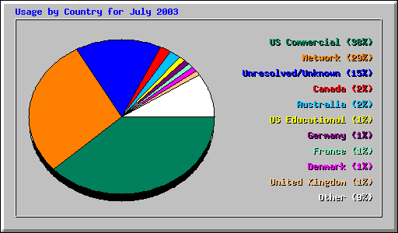
86 Countries or Domains
- Highlights

- Busby’s Manned Submersibles
- 1st PSUBS Convention
- Camaraderie
- Growth

And Lowlights

- A lot of work
- Flame wars
- Having to stomp on off topic, inflammatory, or abusive topics
- Sensitive personalities

Future

- Continued growth
- More conventions – Next year on West Coast
- Build my own submersible

